|  |
| --- |
| Teacher: Deondra M. Seamon, Oriskany Teachers Association  Lesson Title:Understand a Fraction as a Number on a Number Line  Grade:3  Subject: Math  Time Frame:4 days  Planning and Preparation:   * Student Journals * Pre-Assessment Worksheet (Student Resource 1) * Pre-Assessment Worksheet Answer Key (Teacher Resource 1 ) * Students placed in small groups according to Pre-Assessment Scores * Fraction Cards (Teacher Resource 2) * Tiered Lesson Sheet (Teacher Resource 3) * Blank Number Line Sheet (Student Resource 2) * Number Line Activity Rubric (Teacher Resource 4) * Number Line Poster Rubric (Teacher Resource 5) * Fraction Strips (Extra Resource)   Materials/Equipment needed:   * 4 Fresh Bananas (Pre-cut invisibly by using a needle poked through skin to cut one in ½, one in 1/3rds, and one in 1/4ths. Leave one whole.) * “Magic Banana Knife” (Break the blade off of a plastic knife so that the handle is left. The blade will then be “invisible.” * Chart Paper * SMARTBoard * Computers with Internet access: *Visual Fractions.com*; *ConceptuaMath.com* * iTouches/iPad App: *Number Line* * Computers for Web-based Poster Activity   Learning Standards:  Common Core Learning Standards: 3.NF2a and b  2. Understand a fraction as a number on the number line; represent fractions on a number line diagram. a. Represent a fraction 1/b on a number line diagram by defining the interval from 0 to 1 as the whole and partitioning it into b equal parts. Recognize that each part has size 1/b and that the endpoint of the part based at 0 locates the number 1/b on the number line. b. Represent a fraction a/b on a number line diagram by marking off a lengths 1/b from 0. Recognize that the resulting interval has size a/b and that its endpoint locates the number a/b on the number line.  shifts in relation to common standards: This lesson incorporates all of the pedagogical shifts demanded by the Common Core State Standards   * Focus * Coherence * Fluency * Deep Understanding * Application * Dual Intensity   Content objectives:  Prior to lessons, students will develop an understanding of fractions, beginning with unit fractions; 3.NF.1. Students should view fractions in general as being built out of unit fractions, and use fractions along with visual fraction models to represent parts of a whole. Using 3.NF.2a and b, students will have an understanding: fractions are numbers that can be represented on a number line and whole numbers can be partitioned into equal parts.  Essential Question(s):   * How can a whole number be broken into equal parts? * What does partition mean? * Does this make sense?   Academic Vocabulary:   * Equal parts * Partitioned * Number line * Interval * Endpoint   Differentiated Instruction:  The differentiation will be used throughout each day of the lesson for all students, including English Language Learners and students with disabilities. Students will work in group activities according to their level of knowledge of fractions, as seen in the pre-assessment.   * Group activities * iTouch/iPad/Website activities * Tiered Groups * Performance Task (Posters)   Sequence of Lesson activities:  **Day 1: Pre-Assessment (15 min.)**   * Students will complete a Fraction Pre-Assessment. This will determine students’ knowledge of fractions. * Distribute Pre-assessment worksheet to each student. (Student Resource 1) * Read directions to students. * Allow students approximately 15 minutes to complete. * Pre-Assessment answer key in Teacher Resource 1. * **Whole Group Number Line Fraction Activity (20 min.)** * Gather students in large standing oval around masking tape number line attached to the classroom floor. * Give students a fraction flash card one at a time (Teacher Resource 2). * Each student in turn will place their fraction card in the approximate location on the number line. * As the students prepare to place their card, ask each, “Is that a large or small fraction? Will it be closer to 0, ½, or 1?” * Students identify the value of the following fractions: 1/4, 1/3, 2/3, 1/2, 3/4, 1/12, 1/6, 2/6, 4/6, 6/6, 6/12, 1/8, 2/8, 4/8, 6/8, 11/12, and 12/12. * **Student Journal Activity (10 min.)** * Students will answer the following question in their journals: “Explain where would the fraction 3/5 be placed on a number line? Describe how you know”   **Day 2: Tiered Group Activities (50 min.)**   * Complete “Magic Banana Knife” introduction activity with whole class (10 min.) * Show the students a banana and explain that the banana can be cut into fractional parts with a “Magic Banana Knife.” * Pick 3 students to “cut” one banana in half, another in thirds, and the final banana into fourths. * Ask, “Where should the banana be cut for each fraction and how many pieces will be produced by the cuts?”      * Students will be placed in tiers according to their pre-assessment score. In each tier, students will demonstrate their understanding of fractions as locations on number lines, at their level of knowledge. See Tiered Lesson Activities on Teacher Resource 3. * Student Journal Activity (10 min.)   + After completing the tiered activity with their group, students will answer the following question in their journals: “Ella decided to walk 2 ½ miles on a trail. After each ½ mile she stopped to rest. How many times did she stop? Show your solution using a number line.”   + Students will share their journal entry with Tiered Group.   **Day 3: Technology Activities (40 min.)**   * In a whole class setting with the SMARTBoard, use the Ordering Fractions Tool on <http://www.conceptuamath.com/fractions/ordering-fractions-number-line.html> for number lines. This tool should help students build a conceptual understanding of the value of fractions on a number line. * Using the three tiered groups, students will rotate between two groups of computers and/or laptops and one group of iPod Touches or iPads. During 15-minute time slots, students will rotate to complete the following activities on computers or laptops and iPod Touches/iPads:   [**http://www.visualfractions.com/IdentifyLines/identifylines.html**](http://www.visualfractions.com/IdentifyLines/identifylines.html)**,**  [**http://www.conceptuamath.com/fractions/ordering-fractions-number-line.html**](http://www.conceptuamath.com/fractions/ordering-fractions-number-line.html)**,**and the *Number Line App*.   * After the class completes the three rotations, have the students construct number lines (Student Resource 2) into halves, thirds, fourths, fifths, sixths, eighths, tenths, and twelfths. Students will label all intervals from zero to one on each number line. * Teacher will use Number Line Activity Rubric (Teacher Resource 4) to assess the students’ individual understanding of the concept.   **Day 4: Number Line Posters (40 min.)**   * Students with a partner will use chart paper or web products to create a poster of fractions on number lines. * Students create posters with fractions shown on number lines. * A number line will need to be created for each of the fraction sets (denominators 2-10). * See Number Line Rubric (Teacher Resource 5) for poster grading guidelines. * When completed, students will share their poster with the class.   assessment:  ***Formative Assessments***   * Fraction Pre-Assessment * Teacher Observations * Class Discussions * Group Activities * Journal Entries * iPod Touch/iPad/Website Activities   ***Summative Assessments***   * Number Line Activity/Rubric * Number Line Posters/Rubric   Reflection:  ***Process:***  This lesson was chosen since third graders are required to develop Understanding of Fractions as numbers. This is one of the four critical areas of instructional time in Third Grade Common Core Mathematics.    When writing this lesson, I decided that students needed to be in engaged by using the following: Modeling, Differentiation, Technology, and Journal Writing.   * Modeling; Some students need to use fraction models to represent parts of a whole and in use on number lines. They might need to rely on using concrete objects or pictures to help conceptualize and solve a problem. Using the models will help the students check their answers to the problems. They can ask themselves, “Does this make sense?” Models may help them to answer the question. This will help them to follow the First Mathematical Shift of Focus. Students can focus deeply on only the concepts that are prioritized in the standards so that they may reach strong foundational knowledge and deep conceptual understanding. * Differentiation: The students will be placed into tiered small group activities by the level of their understanding of fractions. The teacher facilitating the activities by level is important for all students, especially English Language Learners and students with disabilities. The students will be able to develop understanding of the concept of fractions at their level of ability. * Technology: I believe that the use of technology in this lesson is important for the students to apply their understanding. While using this, students are able to take responsibility for their learning outcomes. It lends itself as a multidimensional tool that assists in that process. Students can apply their understanding of the concepts by using different opportunities of technology; SMARTBoard, websites, iPads, iTouches and computers. * Journal Writing: Writing in journals help students to demonstrate understanding of concepts. They are able to explain the procedures that they used, justify their reasoning, and reflect upon their thinking. When writing occurs in mathematics, students are actively engaged in thinking and learning about the concept. In the Common Core Standards, students need to be able to show a Deeper Understanding of the concepts. This can be achieved by the students writing about their learning.   Applying these procedures to achieve the Mathematical Shifts may be difficult for some educators. They may need to change their “way” of teaching, but in the end, it will improve our students’ learning and understanding of concepts.  *Resources Bibliography:*  *Elizabeth B. Stone, St. Mary’s Elementary School, Anne Arundel County, Maryland and*  *Shelby Leilich, Maryland School for the Deaf*   * *Student Resource 1* * *Teacher Resources 1 and 2*   *Math-Aids.com*   * *Student Resource 2*   *Super Teacher Worsheets.com*   * *Extra Resource page*   *Scott McKinnon, Harlan Elementary School, Florence City*  *Lesson Plan ID: 26348*   * *Teacher Resource 5* |

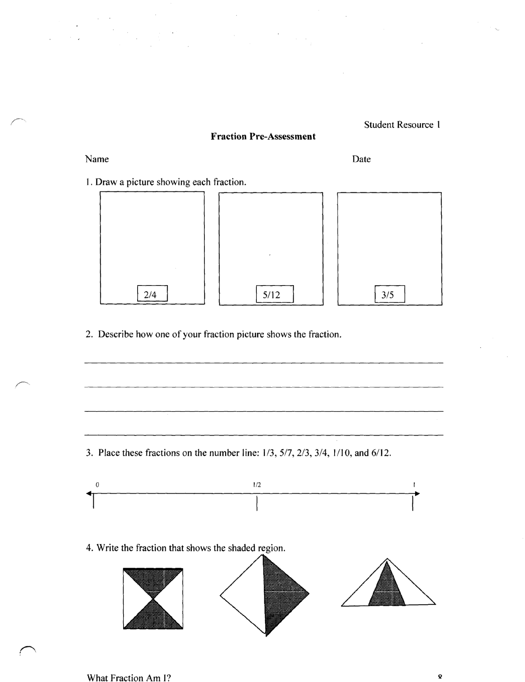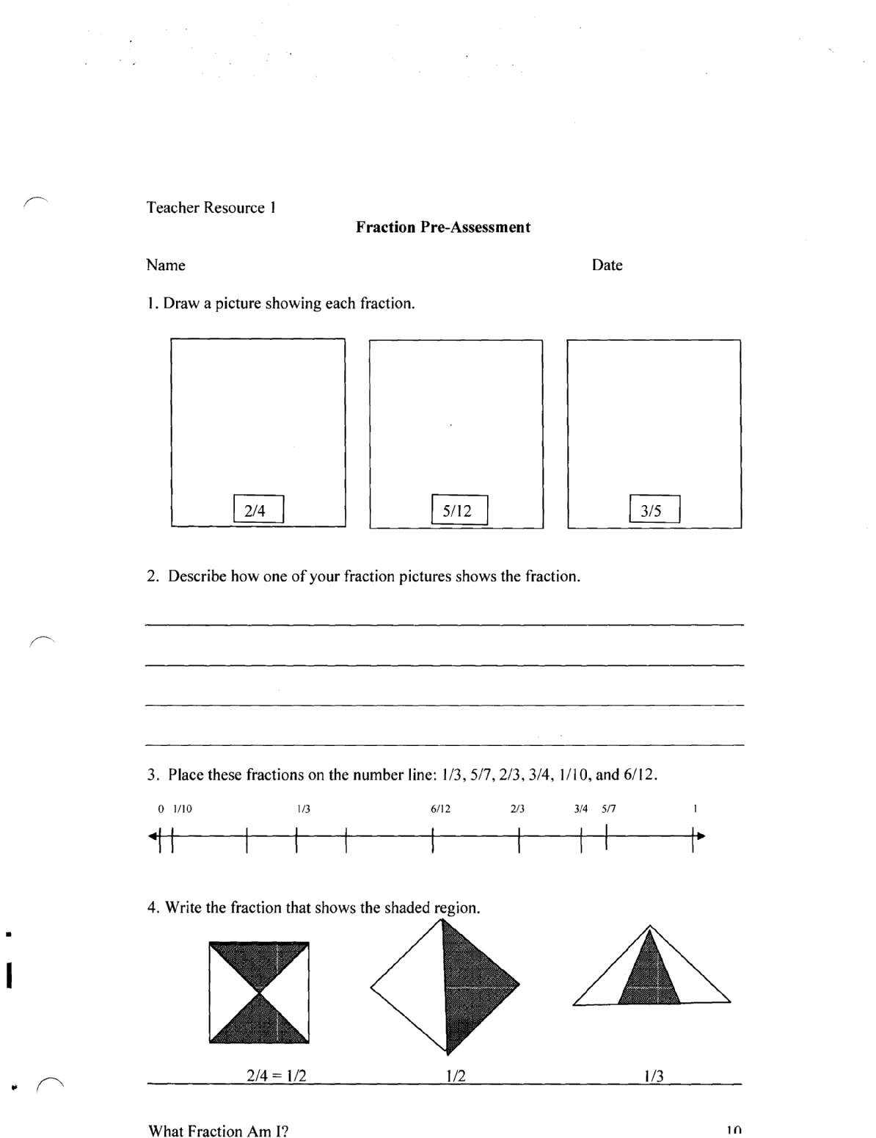

Teacher Resource 2

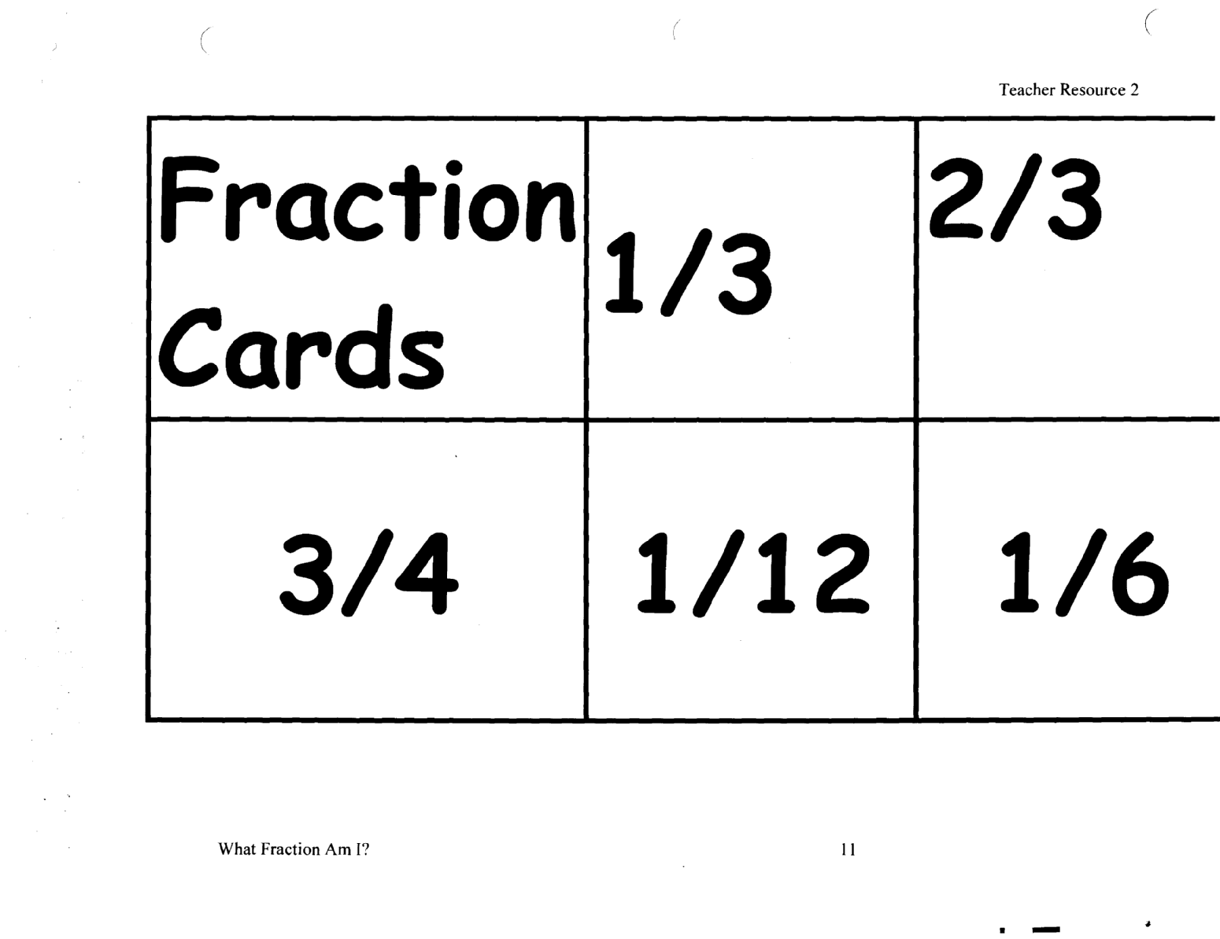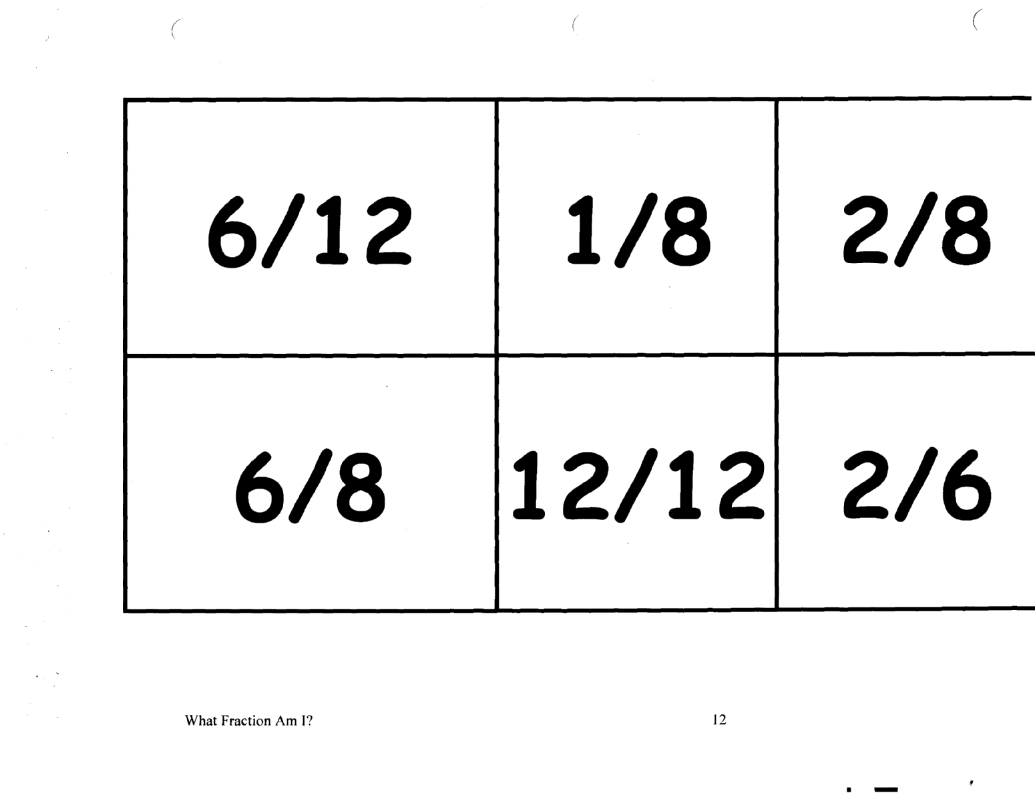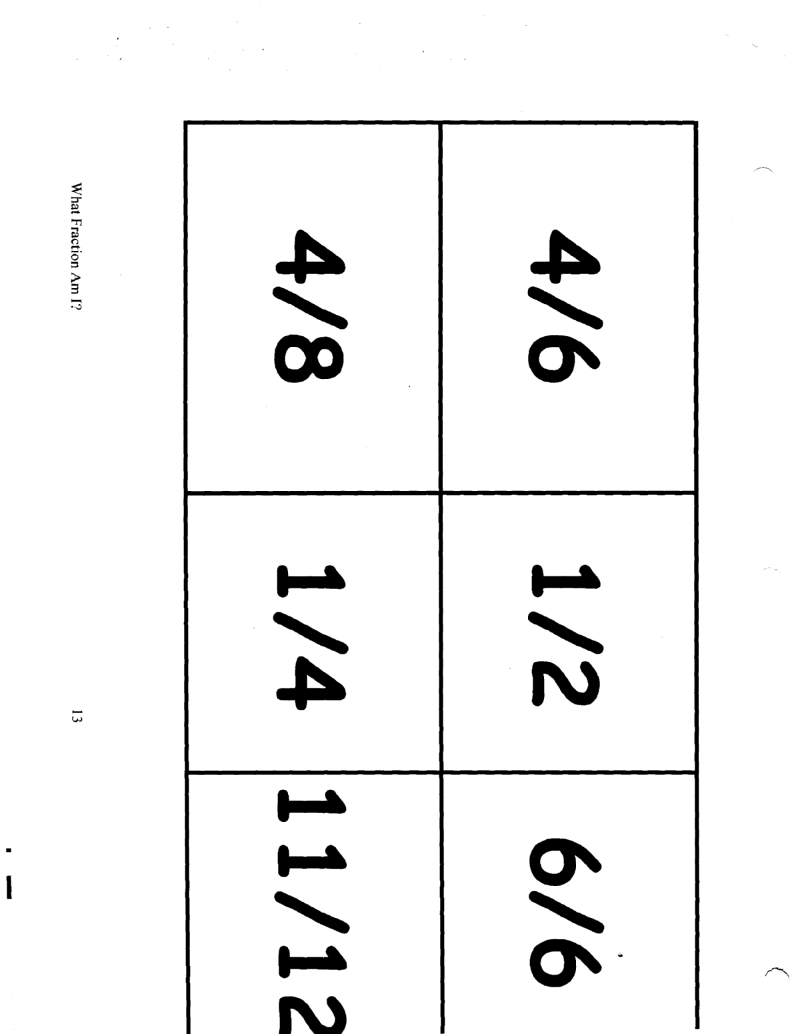

Student Resource 2



Teacher Resource 3

**3rd Grade Fractions on a Number Line**

**3.NF2a Rubric**

|  |  |  |  |  |
| --- | --- | --- | --- | --- |
|  | **Beginning**  **1** | **Developing**  **2** | **Mastery**  **3** | **Score** |
| Understand a fraction as a number on a number line; represent fractions on a number line diagram | Description of identifiable performance characteristics reflecting a beginning level of performance. | Description of identifiable performance characteristics reflecting development and movement toward mastery of performance. | Description of identifiable performance characteristics reflecting mastery of performance. |  |
| Represent a fraction 1/b on a number line | Demonstrates limited  understanding of the concepts: fractions as  equal parts of a  whole on a number line | Demonstrates some  understanding of the  concepts: fractions as  equal parts of a  whole on a number line | Demonstrates thorough  understanding of the concepts: fractions as  equal parts of a whole on a number line |  |
| Recognize that each part has size 1/b | Applies knowledge  and skills with limited  effectiveness when:   * recognizing equal parts * identifying fractional parts | Applies knowledge  and skills with some  effectiveness when:   * recognizing equal parts * identifying fractional parts | Applies knowledge and skills with a high degree of effectiveness  when:   * recognizing equal   parts   * identifying fractional   parts |  |
|  |  |  |  | Total  Score: |

Student Resource 3

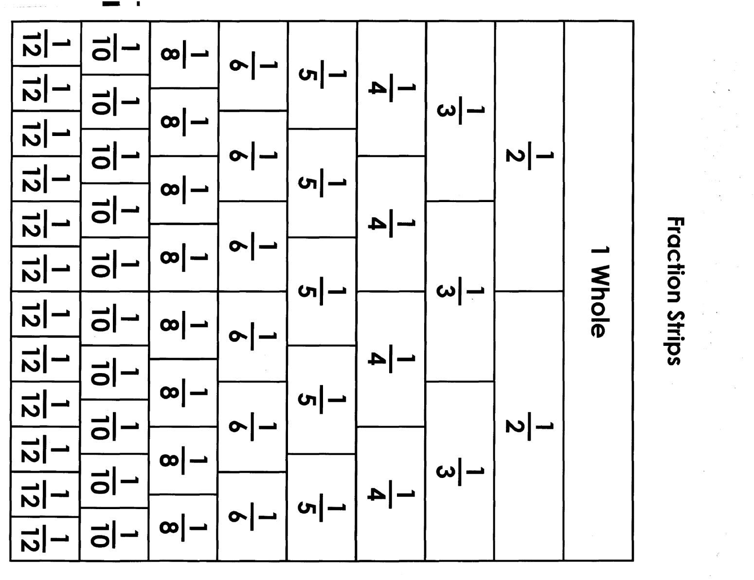

Teacher Resource 4

**Tiered Mathematics Activity for Grade 3**

New York State Mathematics Learning Standards Performance Indicator: 3.NF.2a/b

**Know:** extend the concept of the number line when applying fractions.

**Understand**: identify where fractions are located on number lines.

**Be Able To:** demonstrate how partitioning can assist in placing fractions on a number line.

“Magic Banana Knife” Show the students a banana and explain that the banana can be cut into fractional parts with a “Magic Banana Knife.” Pick 3 students to “cut” one banana in half, another in thirds, and the final banana into fourths. Ask, “where should the banana be cut for each fraction and how many pieces will be produced by the cuts?

**Engaging Whole Group/Hook:**

**Tiered by:**

in product according to readiness of students.

**(e.g. readiness,**

**learning style or**

**interest)**

**Tier I Tier II Tier III**

(Grade Level Learners)

Given blank index cards and masking tape or string, students will construct number lines for the following fractions: ½, 1/3. ¼, 1/5, 1/6, 1/8, 1/10, and 1/12 on the floor. Students will work in groups of 3 during this project.

(Advanced Learners)

Students, in partners, will place fractions on a 4 columned work mat. Each column will be labeled, “Fractions Closest to 0”; “Fractions Closest to ½”; “Fractions Closest to 1”; “Fractions Between 1 and 2”. The following fraction cards will be used for sorting onto the columns: 3/2, 1/3, 3/3, 5/3, ¼, ¾, 6/4, 2/5, 4/5, 3/6, 6/6, 9/6, 4/8, 6/8, 9/8, 6/9, 4/10, 0/12, 4/12, 6/12, 12/12, 1 ¼, and 1 ¾.

(Basic Learners)

Given Fraction Strips (student resource 3) working with partners, students will cut them into pieces. Next the students will place them in to groups according to the denominators. With their partner, they will make individual fraction strips according to denominators. Next using blank number lines (student resource 2), the students will each label each number line using their strips as a guide.

**Activities**

Teacher Resource 5

**Fractions on the Number Line Poster**

|  |  |  |  |  |  |
| --- | --- | --- | --- | --- | --- |
| **Rubric Components** | **Point Scale** | | | | **Student’s**  **Score** |
| **20** | **15** | **10** | **5** |  |
| **Number Lines** | 9 number lines with all fraction sets shown (denominators 2-10). | 7 number lines. | 5 number lines. | 3 or less number lines. |  |
| **Fractions spaced equally on number lines** | All fractions are equally spaced on all number lines. | Most fractions appear equally spaced on number lines. | Few fractions have been equally spaced on number lines. | Fractions do not appear equally spaced on any number line. |  |
| **Fractions placed in the proper order** | All fractions are placed in the proper order. | Most fractions are placed in proper order. | Few fractions are placed in proper order. | No fraction was listed in order. |  |
| **Color** | A different color was used for each number line. | 7 colors used. | 5 colors used. | Black only. |  |
| **Neatness** | Lines straight, all words legible. | Most lines are straight, most words are spelled correctly. | Few lines are straight, many spelling mistakes. | Lines crooked, words illegible. |  |